TITLE: Crypt-DAC_over_Encrypted_Data_Scheme

DECLARATION
ACKNOWLEDGMENTS
ABSTRACT

Many users and organizations using untrusted cloud services find it attractive to enable cryptographically enforced access controls for data. It is challenging to design an efficient cryptographically enforced dynamic access control system. In this paper, a proposal on Crypto-DAC is provided, which uses a system that provides practical cryptographic enforcement of dynamic access control. Here using the symmetric key list, the file is encrypted and this would further record a file key. Cloud service providers (such as Amazon, Microsoft, Apple, etc.) provide abundant cloud-based services, ranging from small-scale personal services or large-scale industrial services. However, recent data breaches, such as releases of private photos, have raised concerns regarding the privacy of cloud-managed data. Actually, a cloud service provider is usually not secure due to design drawbacks of software and system vulnerability. As such, a critical issue is how to enforce data access control on the potentially untrusted cloud. To overcome the mentioned security issues, Crypto-DAC over encrypted data scheme is proposed through which access control on untrusted cloud services is performed to leverage cryptographic primitives.

INTRODUCTION
With the considerable advancements in cloud computing, users and organizations are finding it increasingly appealing to store and share data through cloud services. Cloud service providers (such as Amazon, Microsoft, Apple, etc.) provide abundant cloud based services, ranging from small-scale personal services or large-scale industrial services. However, recent data breaches, such as releases of private photos, have raised concerns regarding the privacy of cloud-managed data. Actually, a cloud service provider is usually not secure due to design drawbacks of software and system vulnerability. As such, a critical issue is how to enforce data access control on the potentially untrusted cloud.

OVERVIEW
The main aim of this project is to propose Crypt-DAC, a system that provides practical cryptographic enforcement of dynamic access control. However, previous works mainly consider static scenarios in which access control policies rarely change. The previous works incur high overhead when access control policies need to be changed in practice. At a first glance, the revocation of a user’s permission can be done by revoking his access to the keys with which the files are encrypted. This solution, however, is not secure as the user can keep a local copy of the keys before the revocation. To prevent such a problem, files have to be re-encrypted with new keys. This requires the file owner to download the file, re-encrypt the file, and upload it back for the cloud to update the previous encrypted file, incurring prohibitive communication overhead at the file owner side.

Literature review:
The present cryptographically enforced access control schemes can be classified as follows:
Hierarchy access control – “Ehud Gudes” [2] from “Ben-Gurion University of the Negev” has mentioned in his IEEE paper “The Design of a Cryptography Based Secure File System” that it is possible through Cryptography [8] to enforce hierarchy access control without considering dynamic policy scenarios. “S. G. Akl and P. D. Taylor” [3] from Queen's university Canada have mentioned in their IEEE paper "Cryptographic solution to a problem of access control in a hierarchy" that oppose a key assignment scheme to simplify key management in hierarchical access control policy. Also, this work does not consider policy update issues. Later, “M. J. Atallah, M. Blanton, N. Fazio, and K. B. Frikken” [4] through their IEEE paper “Dynamic and efficient key management for access hierarchies” propose a method that allows policy updates, but in the case of revocation, all descendants of the affected node in the access hierarchy must be updated, which involves high computation and communication overhead.
Role-based access control [9]: "L.Ibraimi" [5] in his Ph.D. thesis "Cryptographically support role-based access control" has mentioned that structure using mediated public encryption. However, their revocation operation relies on additional trusted infrastructure and an active entity to re-encrypt all affected files under the new policy. Similarly, “A. L. Ferrara, G. Fuchsbauer, and B. Warinschi” [6] define a secure model to formally prove the security of a cryptographically enforced RBAC system. They further show that an ABE-based construction secures under such a model. However, their work focuses on theoretical analysis

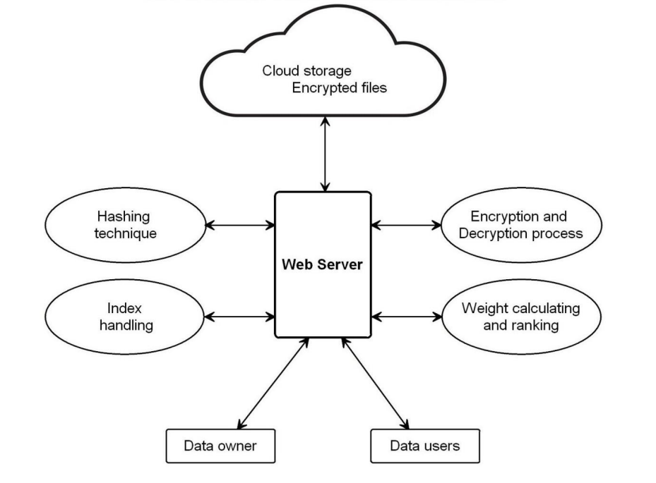
MAIN BODY:
Subheadings specific to your applied research project as agreed with supervisor

Methodology:
Web-Server
Cloud Storage
Encryption and Decryption process
Weight calculating and ranking
Data users
Data owner
Index handling
Hashing technique

Particularly in this proposal, we will make use of “Drive-HQ” as a cloud-storage option to furnishes FTP server hosting service. DriveHQ as a File-Manager can be used in an Android environment to provide enterprise file management, sharing, and backup tool. Here, it can manage local files, cloud files and folders shared with users. It is not just an application, but it is a part of DriveHQ's one-stop cloud IT solution.
A hash function will be used, which has an algorithm that takes an arbitrary amount of data input (can be called a credential) and it produces a fixed-size output of enciphered text called a hash value, or just “hash”. This particular enciphered text can further be stored instead of the password itself and can be used to verify the user Hashing is designed to solve the problem of needing to efficiently find or store an item in a collection. Generally, hashing means using some algorithm that is used to map object data to some representative integer value. This hash code can then be used as a way to narrow down the search when looking for the item in the map. These hash codes are further used to generate an index, at which the value is stored.
Cryptography [8] will be used here for secure communication from outside observers. To make this happen we make the use of Encryption [12], which is the process of translating the plain text into ciphertext, which is not understandable. Decryption is the process of converting ciphertext back to plaintext for which a key is used to decrypt the encrypted message. Through this, we achieve more robust connections to elevate one’s privacy. The goal here is to have every encryption algorithm is to make it as difficult as possible to decrypt the generated ciphertext without using the key.
Through index, handling will be making the best use of Search-Index. As it is well known in Google whenever a word is typed within seconds search results are displayed. This is all possible because of the fast phased internet which is working as a backbone. In the traditional method, indexes are observed in books that are created by the author(s), and editors but also by professionals specialized in indexing, so-called indexers. To sum up, about Search-Index, it is to find information with little effort and fast using a keyword. A search index is critical in creating relevant search results.
Natural Language Processing (NLP) search will be used. This method will strive to process and build a system that understands and respond to the text data in much of the same way as humans do. This also helps in identifying the particular keywords a user is trying to find in less time. This type of search combines the computational linguistics of rule-based modeling of human language having deep learning and machine learning models. With these technologies, the computer enables to process human language in the form of text or voice data.

IMPLEMENTATION TECHNOLOGIES
To accomplish the mentioned proposal, following software requirements are proposed:
- Operating system: Windows 10/11
- Coding Language: Python
- Micro web framework: Flask
- Database: My-SQL 7/8
- UGI for DB: SQLyog
- Cloud Storage: Drive-HQ
Python Introduction:
Python is an easy to learn, powerful programming language. It has efficient high-level data structures and a simple but effective approach to object-oriented programming. Python’s elegant syntax and dynamic typing, together with its interpreted nature, make it an ideal language for scripting and rapid application development in many areas on most platforms. The Python interpreter and the extensive standard library are freely available in source or binary form for all major platforms from the Python Web site, https://www.python.org/, and may be freely distributed. The same site also contains distributions of and pointers to many free third party Python modules, programs and tools, and additional documentation.
The Python interpreter is easily extended with new functions and data types implemented in C or C++ (or other languages callable from C). Python is also suitable as an extension language for customizable applications. Python is a high-level, interpreted, interactive and object-oriented scripting language. Python is designed to be highly readable. It uses English keywords frequently where as other languages use punctuation, and it has fewer syntactical constructions than other languages.
- Python is Interpreted − Python is processed at runtime by the interpreter. You do not need to compile your program before executing it. This is similar to PERL and PHP.
- Python is Interactive − you can actually sit at a Python prompt and interact with the interpreter directly to write your programs.
- Python is Object-Oriented − Python supports Object-Oriented style or technique of programming that encapsulates code within objects.
- Python is a Beginner's Language − Python is a great language for the beginner-level programmers and supports the development of a wide range of applications from simple text processing to WWW browsers to games.
Features:
Python's features include – All these.
- Easy-to-learn − Python has few keywords, simple structure, and a clearly defined syntax. This allows the student to pick up the language quickly.
- Easy-to-read − Python code is more clearly defined and visible to the eyes.
- Easy-to-maintain − Python's source code is fairly easy-to-maintain.
- A broad standard library − Python's bulk of the library is very portable and cross-platform compatible on UNIX, Windows, and Macintosh
- Interactive Mode − Python has support for an interactive mode which allows interactive testing and debugging of snippets of code.
- Portable − Python can run on a wide variety of hardware platforms and has the same interface on all platforms.
- Extendable − you can add low-level modules to the Python interpreter. These modules enable programmers to add to or customize their tools to be more efficient.
- Databases − Python provides interfaces to all major commercial databases.
- GUI Programming− Python supports GUI applications that can be created and ported to many system calls, libraries and windows systems, such as Windows MFC, Macintosh, and the X Window system of Unix.
- Scalable − Python provides a better structure and support for large programs than shell Scripting
Why python emerging as a leader:
There’s battle out there happening in the minds of aspiring data scientists to choose the best data science tool. Though there are quite a number of data science tools that provide the much-needed option, the close combat narrows down between two popular languages – Python and R. Between the two, Python is emerging as the popular language used more in data science applications.
Take the case of the tech giant Google that has created the deep learning framework called tensor flow – Python is the primary language used for creating this framework. Its footprint has continued to increase in the environment promoted by Netflix. Production engineers at Face book and Khan Academy have for long been using it as a prominent language in their environment.
Python has other advantages that speed up it’s upward swing to the top of data science tools. It integrates well with the most cloud as well as platform-as-a-service providers. In supporting multiprocessing for parallel computing, it brings the distinct advantage of ensuring large-scale performance in data science and machine learning. Python can also be extended with modules written in C/C++.
Where Python becomes the perfect-fit:
There are tailor-made situations where it is the best data science tool for the job. It is perfect when data analysis tasks involve integration with web apps or when there is a need to incorporate statistical code into the production database. The full-fledged programming nature of Python makes it a perfect fit for implementing algorithms. Its packages rooted for specific data science jobs. Packages like Numpy, SciPy, and pandas produce good results for data analysis jobs. While there is a need for graphics, Python’s Matplotlib emerges as a good package, and for machine learning tasks, scikit-learn becomes the ideal alternate.
Why is Python preferred over other data science tools?
It is ‘Pythonic’ when the code is written in a fluent and natural style. Apart from that, it is also known for other features that have captured the imaginations of data science community.
Easy to learn:
The most alluring factor of Python is that anyone aspiring to learn this language can learn it easily and quickly. When compared to other data science languages like R, Python promotes a shorter learning curve and scores over others by promoting an easy-to-understand syntax.
Scalability:
When compared to other languages like R, Python has established a lead by emerging as a scalable language, and it is faster than other languages like Matlab and Stata. Python’s scalability lies in the flexibility that it gives to solve problems, as in the case of YouTube that migrated to Python. Python has come good for different usages in different industries and for rapid development of applications of all kinds.

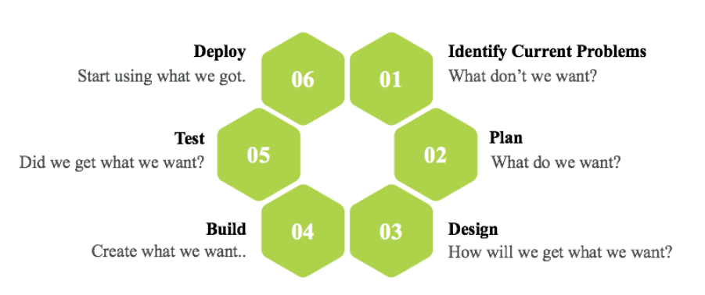

Fig: Software Development Life Cycle

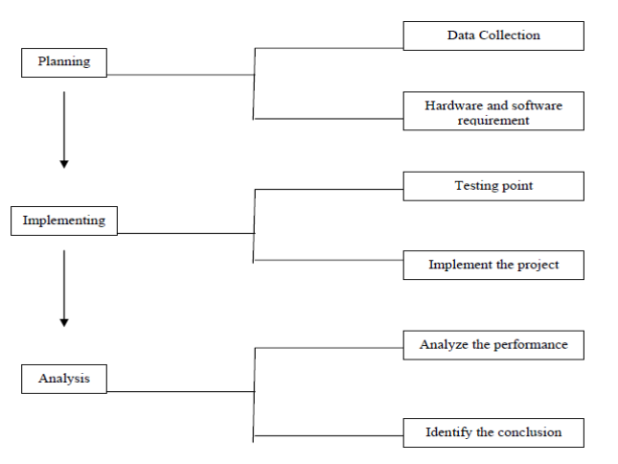
Fig: Steps of Methodology

Planning:
To identify all the information and requirement such as hardware and software, planning must be done in the proper manner. The planning phase has two main elements namely data collection and the requirements of hardware and software.

Work Plan:
The work plan is mentioned in the following graphical representation. This has a data flow depicting the "flow" of data through an information system, modeling its process aspects. This is used as a preliminary step to create an overview of the system and it also visualizes data processing.
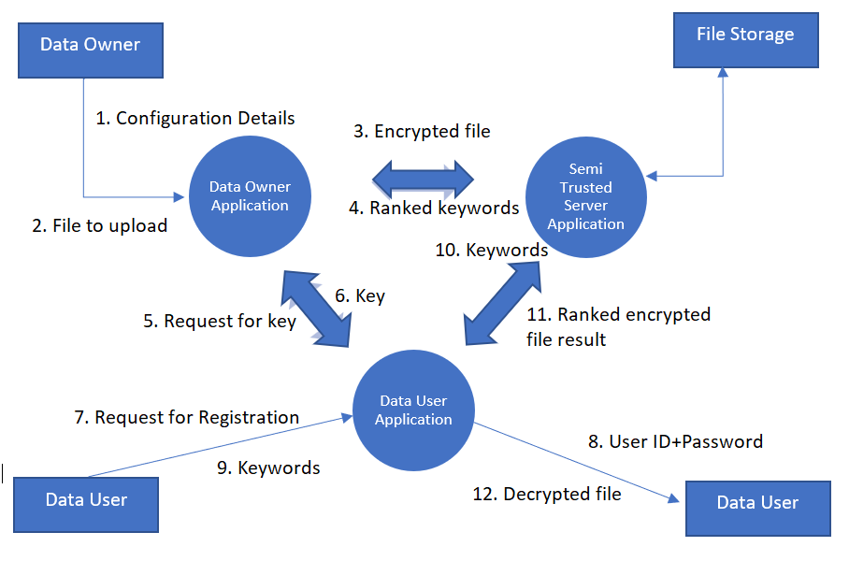

Admin User (Data Owner) Session:
- Login
- Category (View Only)
- Configuration stored in Database
  - File Storage Server Configuration
  - Crypto Key Generation
  - Hash Key Generation
- User Creation
  - Each user comes under a Category
- Upload a file
  - Select the file from the system
  - Provide Access Control
  - Remove unnecessary words
  - Find Keywords
  - Calculate the Content Weight age of keywords
  - Convert the Keywords into Hashcode
  - Place the Hashcode in Index Array
  - Encrypt the File using Crypto Key
  - Upload the encrypted file into the file storage
- View User Details & Edit / Delete user
- Change Password
Data User Session
- Login
- User Profile
- Search with Keyword
Input Search Keyword
  - Convert the keyword into hashcode.
  - Using generate hashcode.
  - Send the Hash codes to the server
  - Based on the Hash codes received server has to check the keyword index and if any matching files are available, list all the file names to the user.
  - View the shorlisted files from Server
  - Download the files
  - Decrypt the file
- Change Password
- logout
Modules Description:
- Access Control:
In this module, Data Owner will provide access control for the files which will further be uploaded. And while uploading, Data Owner will encrypt the file with the help of a master secret key for security purposes to the cloud.

- Keyword Indexing:
Remove unnecessary words from the file and find the keywords. Calculate the Content Weightage of keywords Convert the Keywords into hash code by using hashing algorithm; place the hash code in Index Array.

- SMTP Protocol:
After User creation using Simple Mail Transfer Protocol (SMTP) user credentials are sent to the registered user email ID
- Search with Keyword
The user provides input to the search keyword. This will further convert the keyword into a hashcode. Generated hash codes will be sent to the server. Based on the Hash codes received, the server has to check the keyword index and if any matching files are available, list all the file names to the user. View the shortlisted files from the server, download the files and finally decrypt the file with the owner public key.

CONCLUSION

Through this proposal, the plan is to provide a system that practically enforces cryptography using dynamic access control in the potentially untrusted cloud provider. Considering the practical problem of a privacy-preserving data-sharing system based on public cloud storage which requires a data owner to distribute a large number of keys to users for enabling them to access the documents, for the first time propose the concept of Crypto-DAC over encrypted data scheme. The performed analysis confirms that the work can provide an effective solution to building a practical data-sharing system based on public cloud storage.

APPENDIX
REFERENCES

- [1] F. Wang, J. Mickens, N. Zeldovich, and V. Vaikuntanathan, Sieve: Cryptographically Enforced Access Control for User Data in Untrusted Clouds, in NSDI, 2016.

- [2] E. Gudes, The Design of a Cryptography Based Secure File System, IEEE Transactions on Software Engineering, vol. 6, no. 5, 1980.

- [3] S. G. Akl and P. D. Taylor, Cryptographic solution to a problem of access control in a hierarchy, IEEE TOCS, vol. 1, no. 3, 1983.

- [4] M. J. Atallah, M. Blanton, N. Fazio, and K. B. Frikken, Dynamic and efficient key management for access hierarchies, ACM TISSEC, vol. 12, no. 3, 2009

- [5] L. Ibraimi, Cryptographically enforced distributed data access control, Ph.D. dissertation, University of Twente, 2011.

- [6] A. L. Ferrara, G. Fuchsbauer, and B. Warinschi, Cryptographically
enforced RBAC, in CSF, 2013.

- [7] IEEE document on “Crypt-DAC” https://eprint.iacr.org/2017/090.pdf (Accessed on 10th July 2022)

- [8] Wiki details on Cryptography, https://en.wikipedia.org/wiki/Cryptography (Accessed on 20th July 2022)

- [9] IEEE, “Role Based Access Control models”, https://ieeexplore.ieee.org/document/6976127 (Accessed on 2nd August, 2022)

- [10] F. Wang, J. Mickens, N. Zeldovich, and V. Vaikuntanathan, Sieve:Cryptographically Enforced Access Control for User Data in Untrusted Clouds, in NSDI, 2016

- [11] IEEE, “Crypt-DAC: Cryptographically Enforced Dynamic Access Control in the Cloud” https://ieeexplore.ieee.org/document/8676350 (Accessed: 10th July 2022)

- [12] Wiki details on Encryption, https://en.wikipedia.org/wiki/Encryption (Accessed on 15 July)

